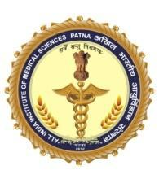
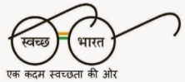
vf[ky Hkkjrh; vk;qfoZKku laLFkku iVuk
ALL INDIA INSTITUTE OF MEDICAL SCIENCES PATNA
(Autonomous institute under Ministry of Health & Family Welfare Government of India)

DATE: /01/ 2022
RECRUITMENT OF FACULTY POSTS FOR VARIOUS DEPARTMENTS AT AIIMS PATNA ON DIRECT RECRUITMENT BASIS.
All India Institute of Medical Sciences, Patna an Autonomous Institute of National Importance is one of the new AIIMS and apex healthcare Institute established by the Ministry of Health & Family Welfare, Government of India under the Pradhan Mantri Swasthya Suraksha Yojna (PMSSY).
Online applications are invited for the following faculty posts on DIRECT RECRUITMENT BASIS in VARIOUS DEPARTMENTS of All India Institute of Medical Sciences, Patna (Bihar). The posts are advertised as per the advertisement numbers mentioned in the relevant column:
SI. No | Advt. No. | Name of Posts | No. of Posts | Category | Name of Department | Qualification
1 | 01/2022 | Professor | 01 | OBC-01 | ENT | Refer Sl. No. I
2 | 02/2022 | Professor | 02 | UR-01  SC-01 | Paediatrics | Refer Sl. No. I
3 | 04/2022 | Associate Professor | 01 | UR-01 | Physical Medicine & Rehabilitation | Refer Sl. No. IV
4 | 03/2022 | Professor | 01 | UR-01 | Trauma & Emergency (Emergency Medicine) | Refer Sl. No. V
SUPER-SPECIALITY
Sl. No | Advt. No. | Name of Posts | No. of Posts | Category | Name of Department | Qualification
5 | 05/2022 | Professor | 01 | OBC-01 | Burns & Plastic Surgery | Refer Sl. No. II
6 | 06/2022 | Professor | 01 | OBC-01 | CTVS | Refer Sl. No. II
7 | 07/2022 | Assistant Professor | 04 | UR-01  EWS-01  OBC-01  ST-01 | CTVS | Refer Sl. No. III
Total |  |  | 11

Note:
- The above vacancies are provisional and subject to variation. The Director, AIIMS, Patna reserves the right to change the vacancies including reserved vacancies as per the Govt. of India rules/circulars and requirements.
- Reservation will be as per Government of India Policy.
- Upper Age Limit shall be counted on the last date of submission of application.
- The period of experience wherever prescribed shall be counted after obtaining the prescribed qualification till the last date of submission of application.
Qualification of the Posts are as under:-
Sl. No. | Name of post | Qualification/Experience
I | Professor | Essential for Medical Candidates (for General Discipline)  Educational Qualification:  - A medical qualification included in the I or II schedule or part II of the third schedule to the Indian medical council Act of 1956 (person possessing qualifications included in part II of third schedule should also fulfil the condition specified in section 13(3) of the Act.)  - A post graduate qualification e.g. MD/MS or a recognized qualification equivalent thereto in the respective discipline/subject.  Experience:  Fourteen years teaching and/or research experience in recognized institution in the subject of specialty after obtaining the qualifying degree of M.D. /M.S. or qualification recognized equivalent thereto.
II | Professor | Essential for Super specialty discipline:-  Educational Qualification:  - A medical qualification included in the I or II schedule or part II of the third schedule to the Indian medical council Act of 1956 (persons possessing qualifications included in part II of third schedule should also fulfil the condition specified in section specified in section 13(3) of the Act.)  - A post graduate qualification e.g. MD/MS or a recognized qualification equivalent thereto in the respective discipline/subject.  - M.Ch. for surgical super-specialties and D.M. for Medical super specialties (2 years or 3 years or 5 years recognized course) or qualification recognized equivalent thereto.  Experience:  Twelve years teaching and/or research experience in recognized institution in the subject of specialty after obtaining the qualifying degree of M.Ch. /D.M. (2years or 5 years course recognized after MBBS) in the respective discipline/subject or a qualification recognized equivalent thereto.  Or  Eleven years teaching and/or research experience in recognized Institution in the subject of specialty for the candidates possessing 3 years recognized degree or D.M/M.Ch. in the respective discipline/subject or a qualification recognized equivalent thereto.
III | Assistant Professor | Essential for Super specialty discipline:-  Educational Qualification  - A medical qualification included in the I or II schedule or part II of the third schedule to the Indian medical council Act of 1956(persons possessing qualifications included in post II of third schedule should also fulfill the condition specified in section 13(3) of the Act.)  - A post graduate qualification e.g. MD/MS or a recognized qualification equivalent thereto in the respective discipline/subject.  - D.M. in respective discipline/subject for medical super-specialties and M.Ch. in respective discipline/subject for surgical super-specialties (2 years or 3 years or 5 years recognized course) or a qualification recognized equivalent thereto.  Experience:  One year teaching and/or research experience in a recognized institution in the subject of specialty after obtaining the qualifying degree of D.M/M.Ch. (2 years or 5 years recognized degree in D.M./M.Ch or qualification recognized equivalent thereto.  No experience is necessary for the candidates possessing the 3 years recognized degree of D.M/M.Ch. or qualification recognized equivalent thereto.
IV | Associate Professor | Essential for Medical Candidates (for General Discipline)  Educational Qualification:  1. A medical qualification included in the I or II schedule or part II of the third schedule to the Indian medical council Act of 1956 (Persons possessing qualifications included in Part II of third schedule should also fulfill the condition specified in section 13(3) of the Act.)  2. A post graduate qualification e.g. MD/MS or a recognized qualification equivalent thereto in the respective discipline/subject.  Experience:  Six years teaching and/or research experience in a recognized institution in the subject of specialty after obtaining the qualifying degree of M.D./M.S. or qualification recognized equivalent thereto.
V | Professor  Trauma & Emergency (Emergency Medicine) | Essential for Medical Candidates (for General Disciplines)  Educational Qualification:  - A medical qualification included in the I or II Schedule or part II of the third schedule to the Indian Medical Council Act of 1956 (persons possessing qualifications included in post II of third schedule should also fulfil the condition specified in section 13(3) of the Act.)  - A Post Graduate qualification i.e. MD in Emergency Medicine with experience in Emergency Medicine.  Fourteen years teaching and/or research experience in a recognized institution in the subject of specialty after obtaining the qualifying degree of M.D. in aforesaid specialties or a qualification recognized equivalent thereto. However, candidates having experience of working in casualty/ Emergency departments will be preferred.

GENERAL CONDITIONS

- Application Process: - The applicants fulfilling the eligibility criteria in all respect are required to apply through ONLINE process. Please visit institute website www.aiimspatna.edu.in for online application. The closing date of online applications will be 30th day from the date of publish of the advertisement of posts in Employment news/Rojgar Samachar.

- A copy of the online application can be downloaded. A print out of the online submitted application is to be self-attested, and sent by Speed post/ Registered post addressed to Recruitment Cell, AIIMS Patna, Phulwarisharif, Patna- 801507. It should be posted by the last date of online submission of application form.

- The applicants are required to register themselves at AIIMS recruitment portal through link available at recruitment page at www.aiimspatna.edu.in.

- After primary registration they will receive a confirmation E-mail. This confirmation e-mail will also have applicant ID and a password to login into the system and fill in the application form online.

- The candidates should read the instruction carefully on the recruitment portal before filling the application.

- The applicants are required to pay a non-refundable application fee of Rs. 1500/-(for General & OBC Candidates) and Rs. 1200/- (for SC/ST/EWS Candidates). There is no fee for PwBD Candidates.

- Application fee once paid shall not be refunded under any circumstances.

- The applicant should upload the scan copy of Photograph, Signature, Date of Birth, Category Certificate (if applicable), Qualification, MCI Registration MBBS, MCI Registration PG, MCI Registration Post Doctorate and Experience Certificate in the form of PDF/Image. The size of each scanned pdf should not exceed 1 MB each.

- The applicants applying in response to this advertisement should satisfy themselves regarding their eligibility for the post applied for. They must be fulfill the eligibility criteria as on the closing date of application failing which their application will be rejected.

- The envelope containing the printout of the online application should be printed/written with: “Application for the post of…………….. (Advt. No)”

- The candidate must ensure that their photo and signature should be clearly visible in preview at the time of filling of application in online mode.

- Pay Scale :

Sl. No. | Name of Posts | Group | Pay Band & Grade Pay
1 | Professor | A | PB-4 (₹ 37,400-67,000) with AGP of ₹10,500 (Pre-revised) corresponding to Level-14-A (₹ 1,68,900-2,20,400) of 7th CPC read with letter no. V-16020/28/2017-INI-I (Pt.) dated 23.08.2018 of MoH&FW, Govt. of India, plus NPA for medically qualified candidates only.  Up to 40% of posts of Professors will get Higher Administrative (HAG) scale Level 15 subject to clearance of the prescribed process
2 | Additional Professor | A | PB-4 (₹ 37,400-67,000) with AGP of ₹ 9,500 (Pre-revised) corresponding to Level-13-A2+ (₹ 1,48,200-2,11,400) of 7th CPC read with letter no. V-16020/28/2017-INI-I (Pt.) dated 23.08.2018 of MoH&FW, Govt. of India, plus NPA for medically qualified candidates only.
3 | Associate Professor | A | PB-4 (₹37,400-67,000) with AGP of ₹ 9,000 (Pre-revised) corresponding to Level-13-A1+ (₹ 1,38,300-2,09,200) of 7th CPC read with letter no. V-16020/28/2017-INI-I (Pt.) dated 23.08.2018 of MoH&FW, Govt. of India, plus NPA for medically qualified candidates only.
4 | Assistant Professor | A | PB-3 (₹ 15,600-39,100) with AGP of ₹ 8,000 (Pre-revised) corresponding to Level-12 (₹1,01,500-1,67,400) of 7th CPC read with letter no. V-16020/28/2017-INI-I (Pt.) dated 23.08.2018 of MoH&FW, Govt. of India, plus NPA for medically qualified candidates only.  After 3 years Assistant Professors will move to level 13 of the Pay Matrix.

- Upper Age Limit:-

Professor/Additional Professor: -Not exceeding 58 (Fifty Eight) years as on closing date.

Associate Professor/ Assistant Professor: - Not exceeding 50 (Fifty) years as on closing date.

- Upper age limit shall be determined as on last date of submission of online applications.

- Upper age limit for person with disabilities shall be as per existing Government of India Rules.
  - Age relaxation permissible to various categories is as under:-

S. No. | Category | Age Relaxation permissible
 |  | beyond the upper age limit
1. | SC/ST | 05 Years
2. | OBC | 03 Years
3. | Person with Disabilities | 05 Years
4. | Government Servant | 05 Years

- Candidate applying under any of the reserved category viz. SC/ST/OBC will be considered subject to submission of valid Caste Certificate on a prescribed format issued by the Competent Authority. The vacancies are being advertised in Financial Year 2021-2022, therefore, valid NCL-OBC Certificate issued during the period from 01.04.2021 to 31.03.2022 will be considered valid. Candidature who have NCL-OBC certificate issued before or after this period (i.e. 01.04.2021 to 31.03.2022), will not be considered valid for this advertisement. Candidates applying under OBC Category must produce the valid caste certificate in the format provided by the DoP&T vide O.M. No. 36036/2/2013-Estt. (Res.) dated 30.05.2014 and further clarification issued by DoPT OM No. 36036/2/2013-Estt.(Res-I) dated 31.03.2016. Certificate must be valid for employment in Central Government Institutions. OBC Candidate's eligibility will be based on Castes borne in the Central List of Govt. of India. Their Sub-caste should also match with the entries in Central List of OBC, failing which their candidature as OBC candidate will not be considered. They will however be treated as UR candidate. The OBC certificate should clearly show that the applicant does not belong to the Creamy Layer. Format for SC/ST and OBC Certificate is attached at APPENDIX-I & APPENDIX-II respectively.

- Central Government civilian employees claiming age relaxation should produce a certificate in the prescribed format from their office at the time of Document Verification, in respect of the length of continuous service which should be not less than three years during the period immediately preceding the closing date for receipt of application. They should remain Central Government civilian employees till the time of appointment, in the event of their selection. (Format is attached as APPENDIX-III).

- Candidates who wish to be considered against vacancies reserved/or seek age relaxation must submit requisite certificate from the competent authority, in the prescribed format when such certificate are sought by the Institute. Otherwise, their claim for SC/ST/OBE/EWS/PwD/EXs status will not be entertained and their candidature/ Applications will be considered under general (UR) category.

- Only such person would be eligible for reservation under PwD quota in service/post who suffer from not less than 40% of disability as identified for that post as per Govt. of India instruction. Person who wants to avail the benefit of reservation would have to submit a Disability Certificate issued by a Competent Authority as notified by the Government in prescribed format.

- IMPORTANT NOTE FOR EWS (ECONOMICALLY WEAKER SECTIONS):

- 10% reservation would be provided for Economically Weaker Sections (EWSs) in central government posts and services, as per the directions of Government of India instructions issued vide DoPT OM No. 36039/1/2019-Estt (Res) dated 19th January, 2019.
- Persons who are not covered under the existing scheme of reservations to the Scheduled Castes, the Schedule Tribes and the Socially and Educationally Backward Classes and whose family has gross annual income below Rs. 8.00 lakh are to be identified as EWSs for the benefit of reservation. Family for this purpose will include the person who seeks benefit of reservation, his/her parents and siblings below the age of 18 years as also his/her spouse and children below the age of 18 years. The income shall include income from all sources i.e. salary, agriculture, business, profession etc. and it will be income for the financial year prior to the year of application. Also persons whose family owns or possesses any of the following assets shall be excluded from being identified as EWSs, irrespective of the family income:
- 5 acres of Agricultural Land and above;
- Residential flat of 1000 sq. ft. and above;
- Residential plot of 100 sq. yards and above in notified municipalities;
- Residential plot of 200 sq. yards and above in areas other than the notified municipalities.

- The income and assets of the families as mentioned in para 2 would be required to be certified by an officer not below the rank of Tehsildar in the States/UTs. The candidates shortlisted for document verification/interview shall be required to bring the requisite certificate as specified by the Government of India at the time of appearing for the process of document verification/interview.

- The instructions issued by the Government of India in this regard from time to time shall be adhered to.

- The vacancies advertised under EWS Category are as per the instructions issued by DoPT, Ministry of Personnel, Public Grievances & Pension, Govt. of India, vide OM. No. 36039/1/2019-Estt (Res), dated 31.01.2019. Application under EWS category will be considered subject to submission of Income & Assets Certificate on a prescribe format issued by the Competent Authority and subject to verification of genuinity of the certificate by issuing authority. As per DoP&T OM No. 36039/1/2019-Estt (Res), dated 31.01.2019, the crucial date for submitting income and asset certificate by the candidate is the closing date for receipt of application for the post, except in cases where date is fixed otherwise. Therefore, a valid EWS certificate will be the one which has been issued by the competent authority, as prescribed by the GOI/DOPT. EWS Certificate issued during the period from 01.04.2021 to 31.03.2022 will be considered valid. Candidates who fail to produce valid EWS Certificate will not be considered for reservation under this Category. They will however, be considered for UR category. Format of EWS Certificate is attached at APPENDIX-IV.

- There shall be 4% horizontal reservation for person with disabilities as per Govt. of India rules. Person who wants to avail the benefit of reservation will have to submit a Disability Certificate issued by a competent authority in prescribed format.

- Clearances: Appointments are subject to clearances as for equivalent posts in Government of India.

- Qualifications and Experience: The qualification and experience will be counted as on last date of submission of application.

- Short Listing: The prescribed qualification is minimum and mere possessing the same does not entitle any candidate for selection. Based on bio-data, the Screening Committee may short-list candidates for interview. Candidates called for interview will have to produce all relevant original documents furnished at the time of application. They may also be asked to submit an affidavit/declaration regarding as decided by AIIMS Patna at the time of interview.

- Interview: Details of the interview will be communicated through registered e-mail provided at the time of registration. No TA/DA will be paid for appearing in the interview.

- The applicants already in Government service shall have to produce Relieving Certificate from their present employer at the time of joining the Institute.

- Considering the number of applicants, AIIMS Patna may decide to hold written examination for the purpose of shortlisting the eligible candidates to be called for interview.
- The decision of AIIMS, Patna in all matters relating to eligibility, acceptance or rejection of the applications, penalty for false information, mode of selection, conduct of examination(s), allotment of examination centers, selection and allotment of posts/organizations to selected candidates will be final and binding on the candidates and no enquiry / correspondence will be entertained in this regard.

- Those who are in government service must submit application through their employer. “NO OBJECTION CERTIFICATE” from the employer at the time of interview should be produced. However, they are free to apply online.

- Any corrigendum or any other information regarding this recruitment will be posted on the Official website of AIIMS Patna only in due course. Candidates are advised to visit our website regularly for updated information in this regard.

- The qualification regarding experience is relaxable at the discretion of the competent authority in the case of candidates belonging to the Scheduled Castes or Scheduled Tribes, if at any stage of selection the competent authority is of the opinion that sufficient number of candidates from these communities possessing the requisite experience are not likely to be available to fill up the vacancies reserved for them. The appointing authority shall record the reasons for relaxing the qualifications regarding experience in writing while doing so.

- OTHER INFORMATION FOR THE CANDIDATES

- The All India Institute of Medical Sciences Patna is an autonomous body established under Act of Parliament. Service under the Institute is governed by that Act and the Rules & Regulations framed there under.
- All the posts carry pay and allowances as admissible in All India Institute of Medical Sciences Patna.
- Probation period: The period of probation is for two years.
- The applicants, who do not have requisite qualifications and experience up to the last date of submission of applications, will not be considered.
- Incomplete application(s) will not be considered.
- The period of experience, wherever prescribed, shall be counted after obtaining the prescribed educational qualification.
- The selected candidates will be governed by the New Pension Scheme as per the provision contained in the Ministry of Finance, Department of Economic Affairs (ECB & PR Division). Notification No. 5/7/2003-ECB&PR dated 22.12.2003.
- The post(s) is/are whole time and private practice of any kind is not permitted.
- AIIMS reserves the rights to increase or decrease the number of vacancies.
- Canvassing of any kind will be a disqualification.
- The candidate should not have been convicted by any Court of Law.
- In case any information given or declaration by the candidate is found to be false or if the candidate has willfully suppressed any material information relevant to this appointment, he/she will be liable to be removed from the service, and any action taken as deemed fit by the appointing authority.
(xiv) The Competent Authority reserves the right to make any amendment, cancellation and changes to this advertisement as a whole or in part without assigning any reason or giving notice.
(xv) The decision of the competent authority regarding interview, verification of documents and selection would be final and binding on all candidates. No representation or correspondence will be entertained in this regard.
(xvi) All disputes will be subject to jurisdiction of Court of Law at Patna.

Clarification & Enquiries:

Mail to: recruitment@aiimspatna.org

Sd/-
DIRECTOR
AIIMS, PATNA

APPENDIX-I
FORMAT FOR SC/ST CERTIFICATE
A candidate who claims to belong to one of the Scheduled Caste or the Scheduled Tribes should submit in support of his claim an attested/certified copy of a certificate in the form given below, from the District Officer or the sub-Divisional Officer or any other officer as indicated below of the District in which his parents(or surviving parent) ordinarily reside who has been designated by the State Government concerned as competent to issue such a certificate. If both his parents are dead, the officer signing the certificate should be of the district in which the candidate himself ordinarily resides otherwise than for the purpose of his own education. Wherever photograph is an integral part of the certificate, the Commission would accept only attested photocopies of such certificates and not any other attested or true copy.
(The format of the certificate to be produced by Scheduled Castes and Scheduled Tribes candidates applying for appointment to posts under Government of India)
This is to certify that Shri/Smt./Kumari* __________________________ son/daughter of ___________________________________ of village/town/* in District/Division *_______________________ of the State/Union Territory* ________ belongs to the Caste/Tribes_______________ which is recognized as a Scheduled Castes/Scheduled Tribes* under:-
The Constitution (Scheduled Castes) order, 1950 ___________________
The Constitution (Scheduled Tribes) order, 1950 ________________
The Constitution (Scheduled Castes) Union Territories order, 1951 * _______________
The Constitution (Scheduled Tribes) Union Territories Order, 1951*______________

As amended by the Scheduled Castes and Scheduled Tribes Lists(Modification) order, 1956, the Bombay Reorganization Act, 1960 & the Punjab Reorganization Act, 1966, the State of Himachal Pradesh Act 1970, the North-Eastern Area(Reorganization) Act, 1971 and the Scheduled Castes and Scheduled Tribes Order(Amendment) Act, 1976.
The Constitution (Jammu & Kashmir) Scheduled Castes Order, 1956___________
The Constitution (Andaman and Nicobar Islands) Scheduled Tribes Order, 1959 as amended
by the Scheduled Castes and Scheduled Tribes order (Amendment Act), 1976*.
The Constitution (Dadra and Nagar Haveli) Scheduled Castes order 1962.
The Constitution (Dadra and Nagar Haveli) Scheduled Tribes Order 1962@.
The Constitution (Pondicherry) Scheduled Castes Order 1964@
The Constitution (Scheduled Tribes) (Uttar Pradesh) Order, 1967 @
The Constitution (Goa, Daman & Diu) Scheduled Castes Order, 1968@
The Constitution (Goa, Daman & Diu) Scheduled Tribes Order 1968 @
The Constitution (Nagaland) Scheduled Tribes Order, 1970 @
The Constitution (Sikkim) Scheduled Castes Order 1978@
The Constitution (Sikkim) Scheduled Tribes Order 1978@
The Constitution (Jammu & Kashmir) Scheduled Tribes Order 1989@
The Constitution (SC) orders (Amendment) Act, 1990@ The Constitution (ST) orders (Amendment) Ordinance 1991@ The Constitution (ST) orders (Second Amendment) Act, 1991@
The Constitution (ST) orders (Amendment) Ordinance 1996
The Scheduled Caste and Scheduled Tribe Orders(Amendment ) Act 2002.
The Constitution (Scheduled Caste) Orders(Amendment) Act 2002.
The Constitution(Scheduled Caste and Scheduled Tribe) Orders(Amendment) Act 2002.
The Constitution (Scheduled Caste) Order (Amendment) Act 2007.
%2. Applicable in the case of Scheduled Castes, Scheduled Tribes persons who have migrated from one State/Union Territory Administration.

This certificate is issued on the basis of the Scheduled Castes/ Scheduled tribes certificate issued to Shri/Shrimati __________________________Father/mother _____________________________ of Shri/Srimati/Kumari*___________________________ of village/town*____________ ___________________ in District/Division* ______________________of the State/Union Territory*_________ _____________________ who belong to the _________________________________ Caste/Tribe which is recognized as a Scheduled Caste/Scheduled Tribe in the State/Union Territory* issued by the_______________________________ ____dated____________________________. %3. Shri/Shrimati/Kumari and /or * his/her family ordinarily reside(s) in village/town*________________________________________ of ________________ District/Division* _________________of the State/Union Territory of ____________________________
Signature__________________________
** Designation________________________
(with seal of office)
Place______________
Date_______________
* Please delete the words which are not applicable
@ Please quote specific presidential order
% Delete the paragraph which is not applicable.
NOTE: The term ordinarily reside(s) used here will have the same meaning as in section 20 of the Representation of the People Act, 1950.
** List of authorities empowered to issue Caste/Tribe Certificates:
  - District Magistrate/Additional District Magistrate/Collector/Deputy Commissioner/Additional Deputy Commissioner/Dy.Collector/Ist Class Stipendiary Magistrate/Sub-Divisional Magistrate/Extra-Assistant Commissioner/Taluka Magistrate/Executive Magistrate.
  - Chief Presidency Magistrate/Additional Chief Presidency Magistrate/Presidency Magistrate.
  - Revenue Officers not below the rank of Tehsildar.
  - Sub-Divisional Officers of the area where the candidate and/or his family normally resides.

NOTE: ST candidates belonging to Tamil Nadu state should submit caste certificate ONLY FROM THE REVENUE DIVISIONAL OFFICER.
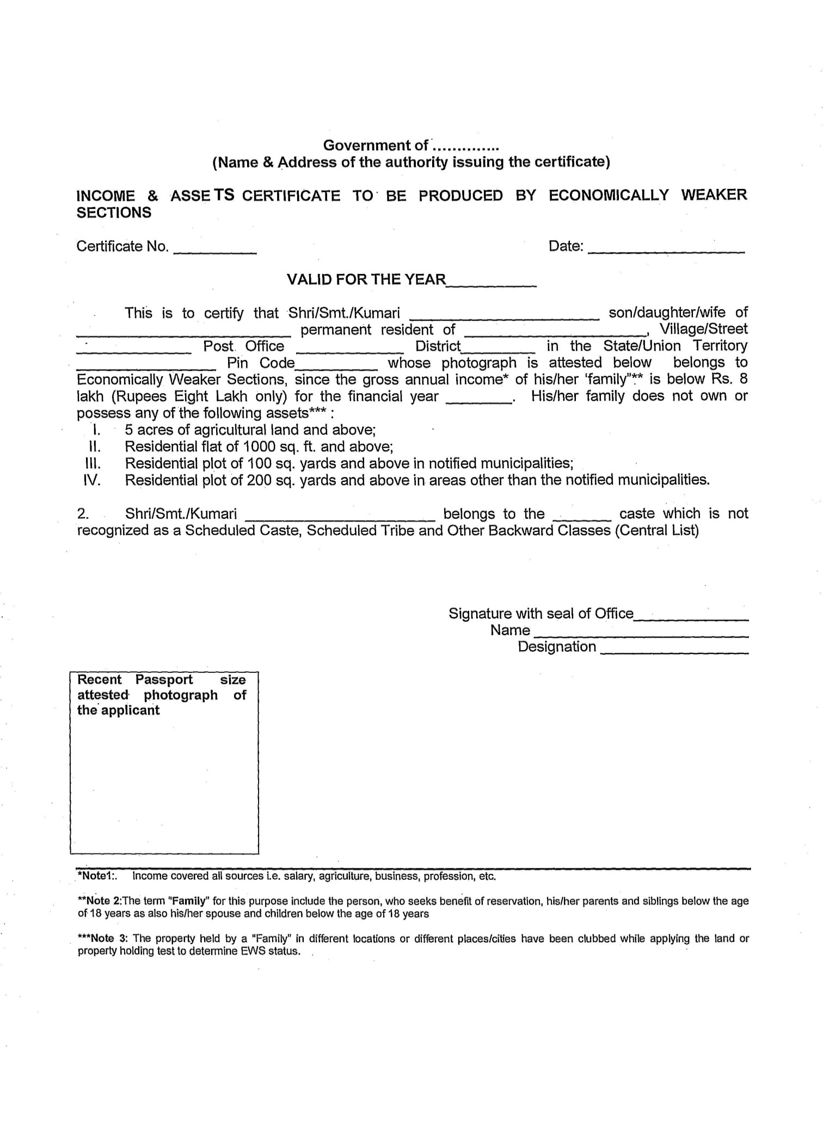
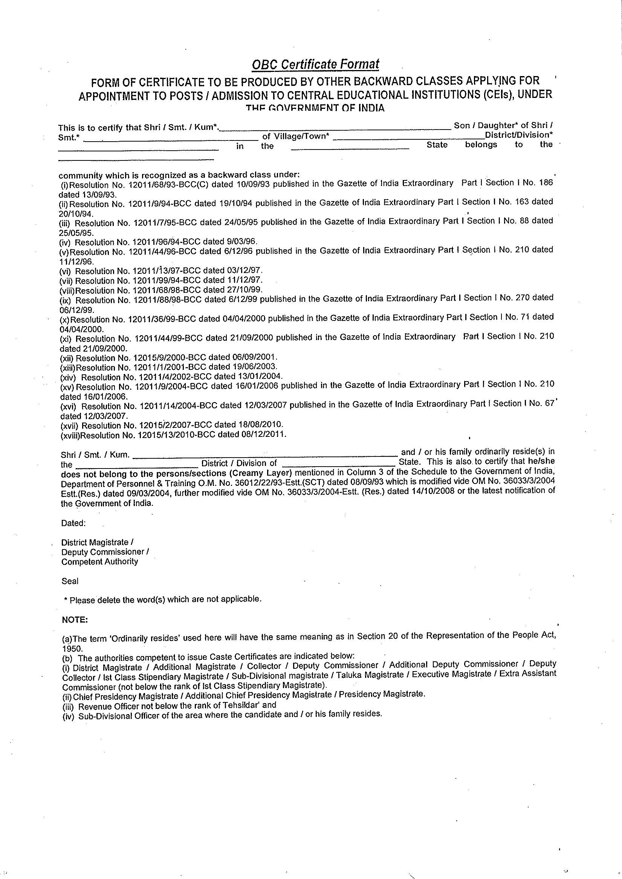
APPENDIX-II
APPENDIX-III

(Format of Certificate to be submitted by Government Employees Seeking Age-relaxation)

(To be filled by the Head of the Office or Department in which the candidate is working)

It is certified that Mr./Ms./Mrs. ___________________________________________ is a Central Government Civilian employee holding the post of _______________________ in the pay scale of Rs. _____________________________ with 03 years regular/continuous service in the grade as ___________________________________________________.
2. There is no objection to his appearing for the post of _______________ and document verification for the said recruitment.

Signature ______________________________
Name _________________________________
Tele No.________________________________
Office Seal _____________________________

Place: __________________
Date:___________________

(*Please delete the words which are not applicable)

APPENDIX-IV

